**Mining Big Data**

Project, Phase 2

NAME: LI HUANG

# Part 1: Data Transformation

Using A cluster of 4 nodes to process data in this part.(command line in red)

hdfs dfsadmin -safemode leave # leave safemode and remove files with the same name from previous homework

wget <http://rasinsrv07.cstcis.cti.depaul.edu/CSC553/data/lineorder.tbl>

wget <http://rasinsrv07.cstcis.cti.depaul.edu/CSC553/data/dwdate.tbl>

wget <http://rasinsrv07.cstcis.cti.depaul.edu/CSC553/data/part.tbl>

wget <http://rasinsrv07.cstcis.cti.depaul.edu/CSC553/data/supplier.tbl>

Produce a sample first: head -n 100 lineorder.tbl > lineorder.tbl.sample

hadoop fs -put lineorder.tbl /data/lineorder_s4.tbl

hadoop fs -put lineorder.tbl.sample /data/lineorder_ss4.tbl

hadoop fs -put dwdate.tbl /data/dwdate_s4.tbl

hadoop fs -ls /data # checked, everything is fine

**A.**

cd $HIVE_HOME

bin/home

try on sample dataset first:

CREATE TABLE lineordersl ( lo_orderkey int, lo_linenumber int, lo_custkey int, lo_partkey int, lo_suppkey int, lo_orderdate int, lo_orderpriority varchar(15), lo_shippriority varchar(1), lo_quantity int, lo_extendedprice int, lo_ordertotalprice int, lo_discount int, lo_revenue int, lo_supplycost int, lo_tax int, lo_commitdate int, lo_shipmode varchar(10) )ROW FORMAT DELIMITED FIELDS TERMINATED BY '|' STORED AS TEXTFILE;

LOAD DATA LOCAL INPATH '/home/ec2-user/lineorder.tbl.sample' OVERWRITE INTO TABLE lineordersl;

INSERT OVERWRITE DIRECTORY '/home/ec2-user/lineordersl.csv' ROW FORMAT DELIMITED FIELDS TERMINATED BY ',' SELECT * FROM lineordersl;

DROP TABLE IF EXISTS lineorder;

CREATE TABLE lineorder ( lo_orderkey int, lo_linenumber int, lo_custkey int, lo_partkey int, lo_suppkey int, lo_orderdate int, lo_orderpriority varchar(15), lo_shippriority varchar(1), lo_quantity int, lo_extendedprice int, lo_ordertotalprice int, lo_discount int, lo_revenue int, lo_supplycost int, lo_tax int, lo_commitdate int, lo_shipmode varchar(10) )ROW FORMAT DELIMITED FIELDS TERMINATED BY '|' STORED AS TEXTFILE;

LOAD DATA INPATH '/data/lineorder_s4.tbl' OVERWRITE INTO TABLE lineorder;

LOAD DATA LOCAL INPATH '/home/ec2-user/lineorder.tbl' OVERWRITE INTO TABLE lineorder;

INSERT OVERWRITE DIRECTORY '/user/ec2-user/lineorder.csv' ROW FORMAT DELIMITED FIELDS TERMINATED BY ',' SELECT * FROM lineorder;

Check out result:

hadoop fs -ls /user/ec2-user/lineorder.csv/

Hadoop fs –head /user/ec2-user/lineorder.csv/

Transform lineorder.tbl table into a csv (comma-separated file)

# TIME ON A SINGLE/CLUSTER NODE FOR QUETSION PART 4. JUST TIME THEM

HIVE:

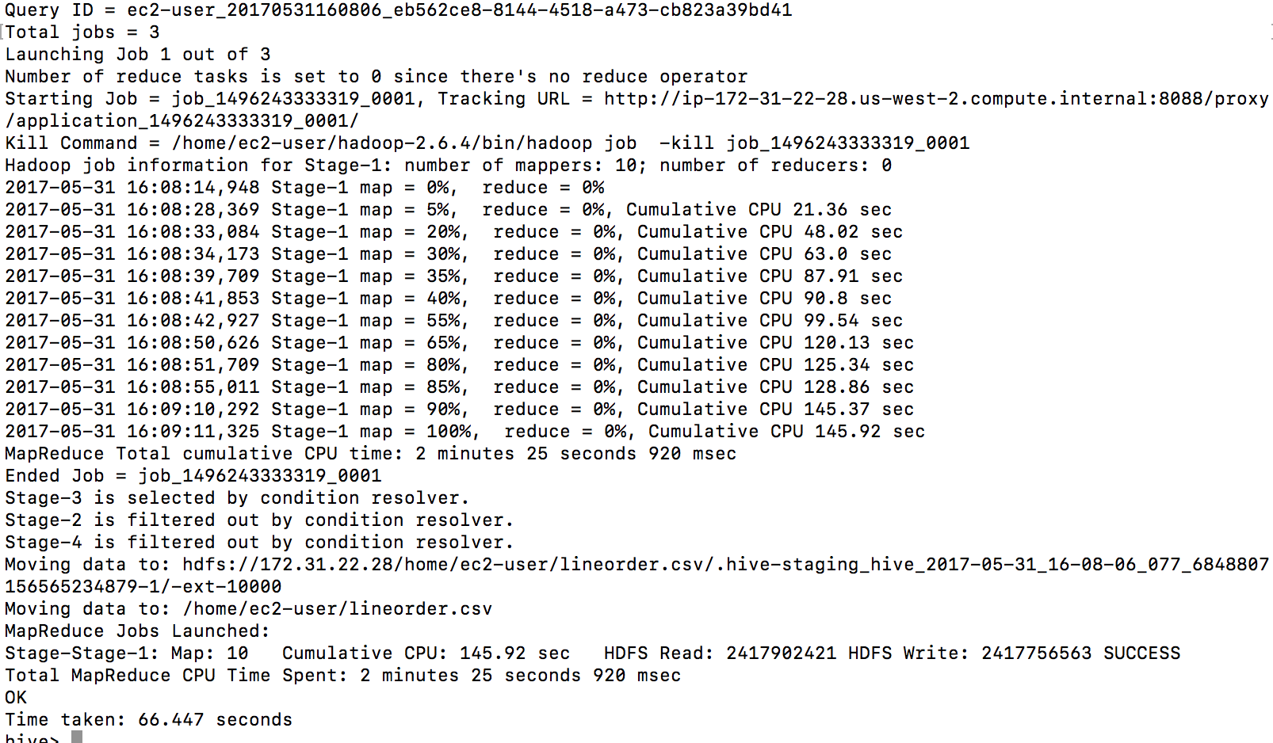

the csv file:

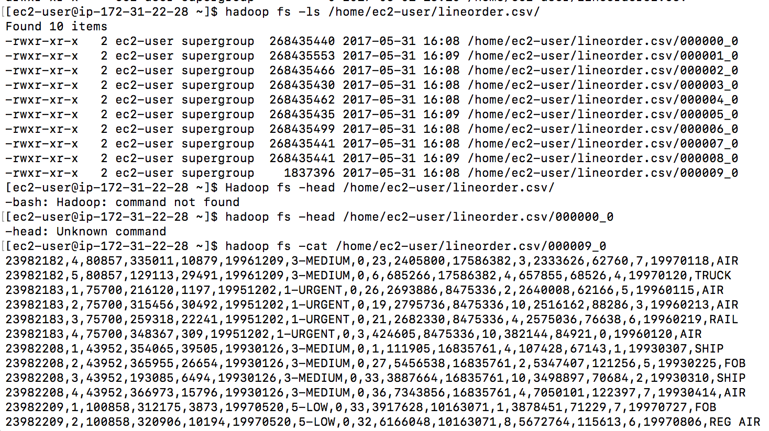

PIG:

lineorder = LOAD '/data/lineorder_s4.tbl' USING PigStorage('|')AS (lo_orderkey: int, lo_linenumber: int, lo_custkey: int, lo_partkey: int, lo_suppkey: int, lo_orderdate: int, lo_orderpriority: chararray, lo_shippriority: chararray, lo_quantity: int, lo_extendedprice: int, lo_ordertotalprice: int, lo_discount: int, lo_revenue: int, lo_supplycost: int, lo_tax: int, lo_commitdate: int, lo_shipmode: chararray);

STORE lineorder INTO '/user/ec2-user/lineorder_pig.csv' USING org.apache.pig.piggybank.storage.CSVExcelStorage();

PIG Time Taken:4 min 9 seconds

Start

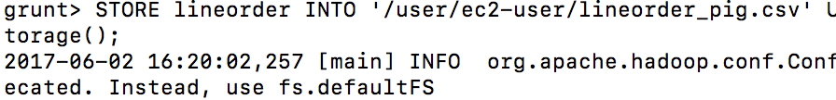

End

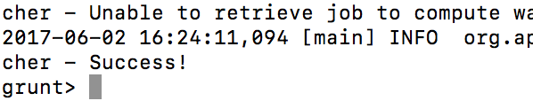

Csv file:

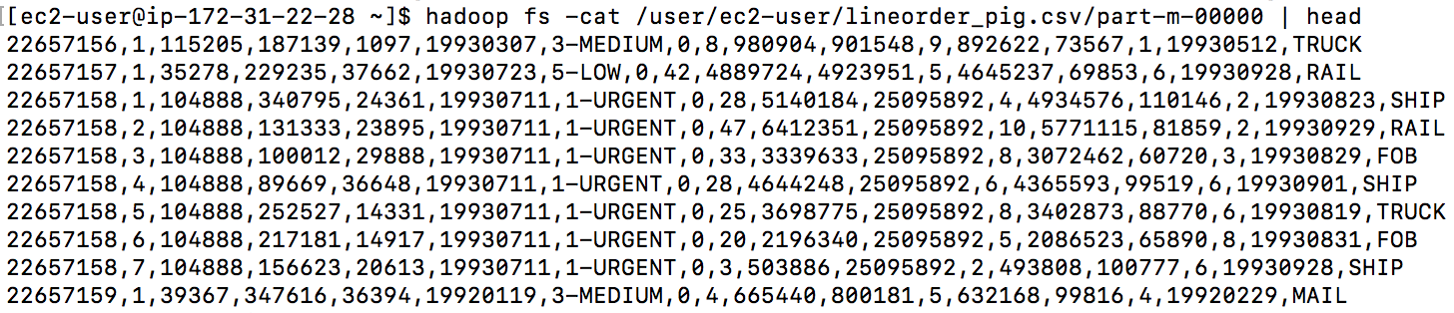

1. Transpose dwdate.tbl table

Python code:

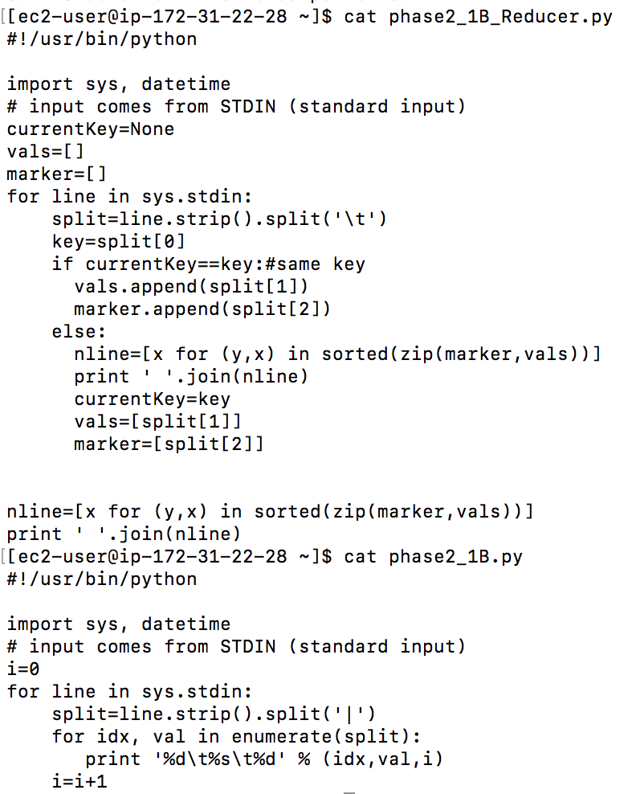

Hadoop jar code:

hadoop jar hadoop-streaming-2.6.4.jar -input /data/dwdate_s4.tbl -output /data/phase2_0 -mapper phase2_1B.py -reducer phase2_1B_Reducer.py -file phase2_1B_Reducer.py -file phase2_1B.py

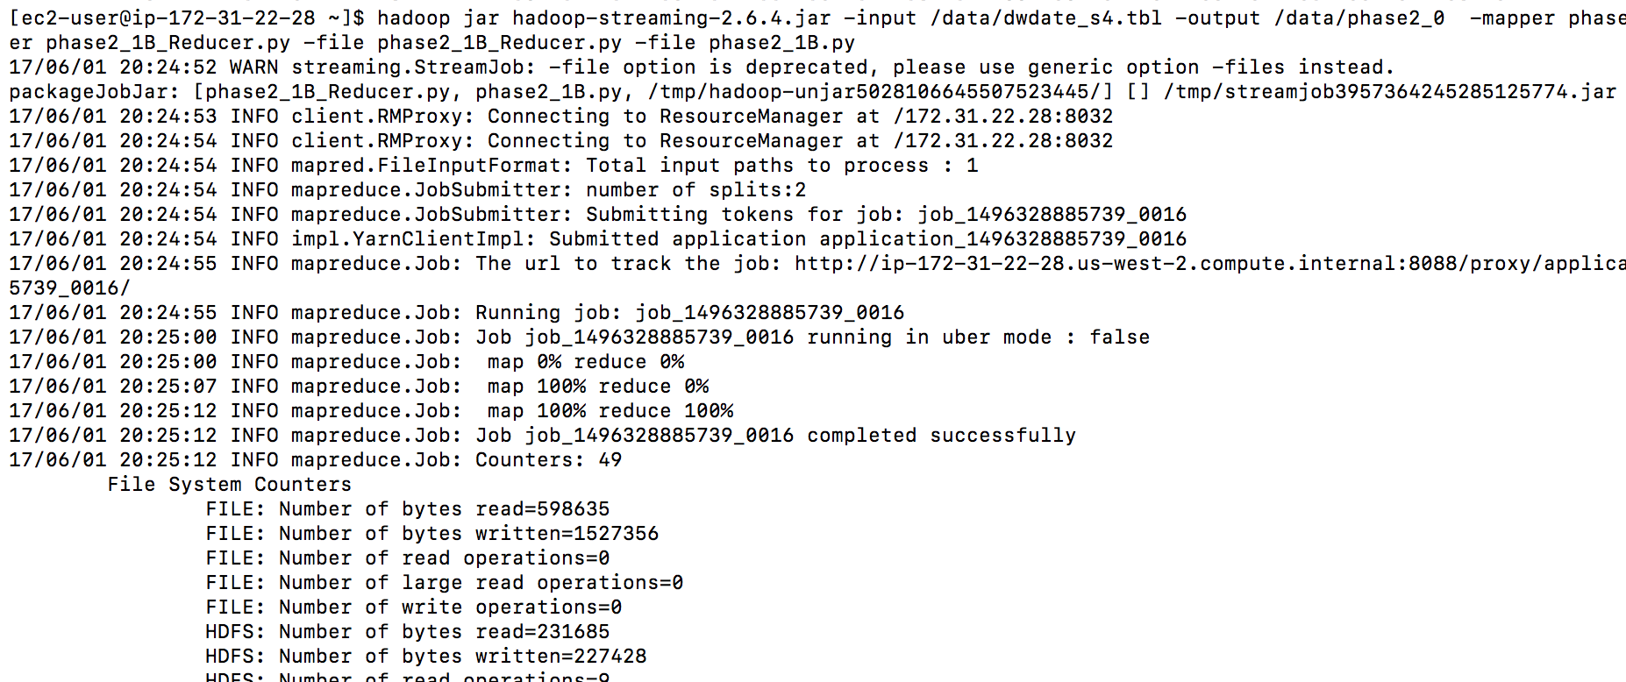

streaming result : ( each column become a line, we can see the first line from the screenshot below)

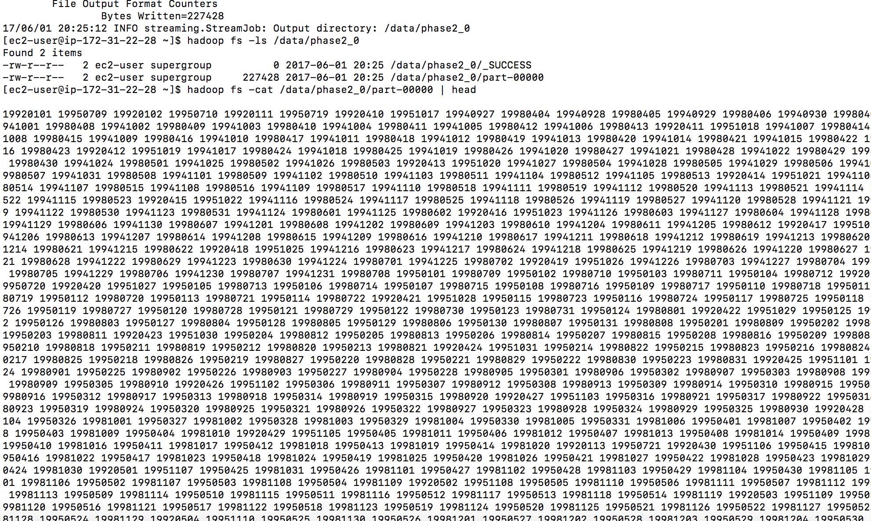

1. Extract all of the numeric columns that **only** contain integer values of < 5000

Return data type for all columns:

DESCRIBE FORMATTED lineorder;

set hive.cli.print.header=true;

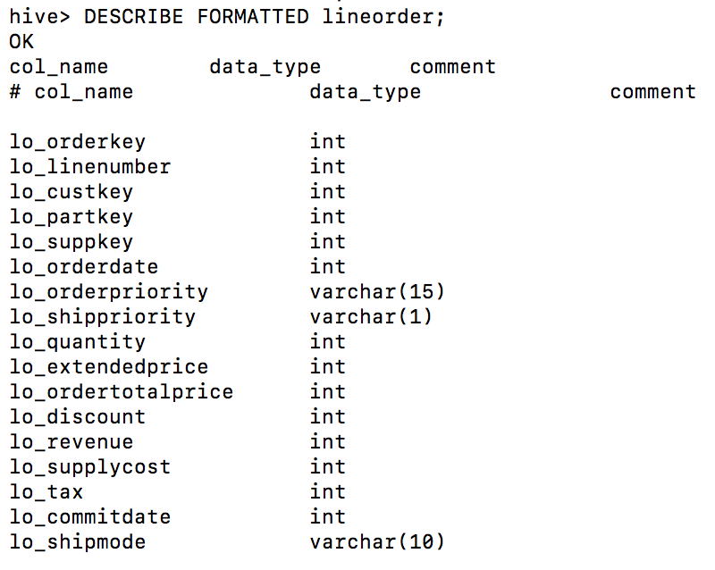

Return max value for all columns of lineorder table, if the max value is less than 5000, then extract the column.

Select max(lo_orderkey), max(lo_linenumber), max(lo_custkey), max(lo_partkey), max(lo_suppkey), max(lo_orderdate), max(lo_orderpriority), max(lo_shippriority), max(lo_quantity), max(lo_extendedprice), max(lo_ordertotalprice), max(lo_discount), max(lo_revenue), max(lo_supplycost), max(lo_tax), max(lo_commitdate), max(lo_shipmode) from lineorder;

Result:

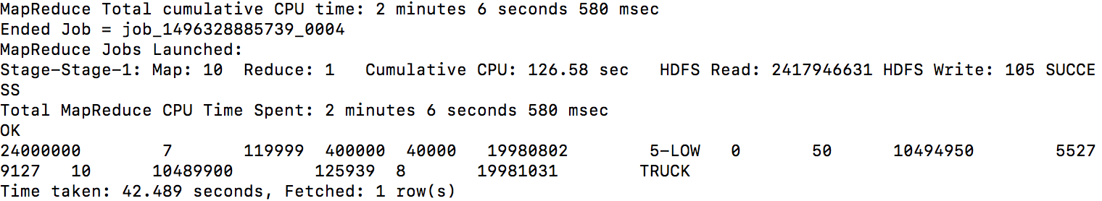

col 2,8,9,13,16, and 8 is not int, so the columns should be extracted are: col(2,5,9,13,16)

lo_linenumber, lo_quantity, lo_discount, lo_tax

INSERT OVERWRITE DIRECTORY 'lo_ss' ROW FORMAT DELIMITED FIELDS TERMINATED BY ' ' SELECT lo_linenumber, lo_quantity, lo_discount, lo_tax FROM lineorder;

Result:

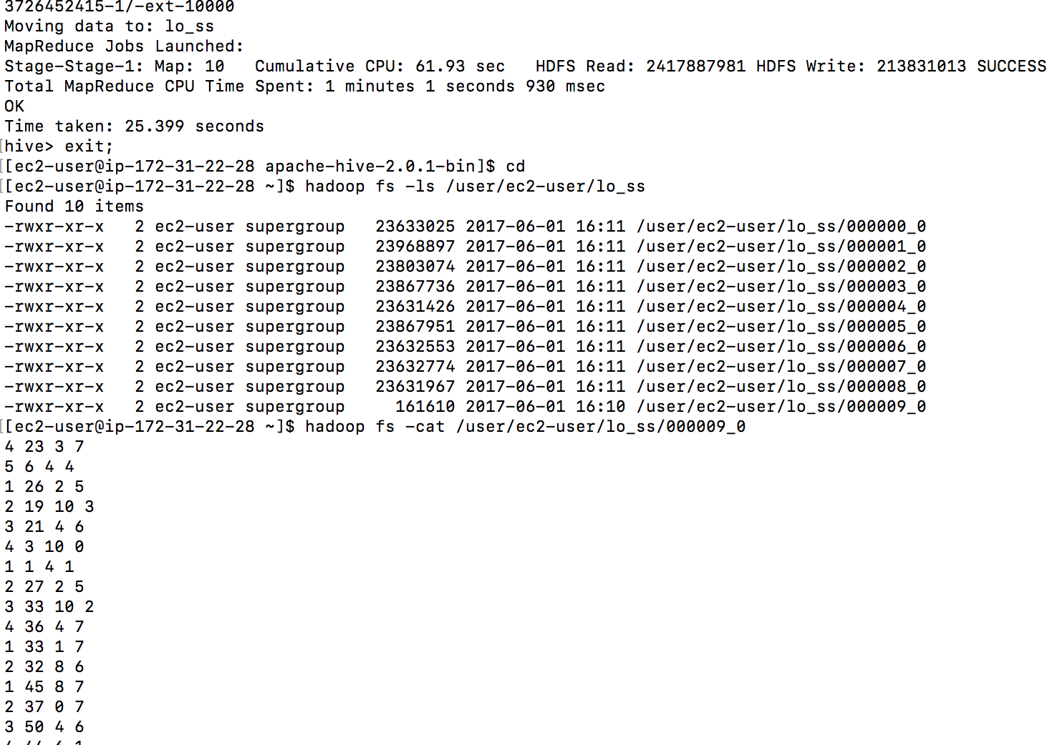

PIG:

LO = GROUP lineorder ALL;

LOMAX = FOREACH LO GENERATE MAX(lineorder.lo_orderkey), MAX(lineorder.lo_linenumber), MAX(lineorder.lo_custkey), MAX(lineorder.lo_partkey), MAX(lineorder.lo_suppkey), MAX(lineorder.lo_orderdate), MAX(lineorder.lo_orderpriority), MAX(lineorder.lo_shippriority), MAX(lineorder.lo_quantity), MAX(lineorder.lo_extendedprice), MAX(lineorder.lo_ordertotalprice), MAX(lineorder.lo_discount), MAX(lineorder.lo_revenue), MAX(lineorder.lo_supplycost), MAX(lineorder.lo_tax), MAX(lineorder.lo_commitdate), MAX(lineorder.lo_shipmode);

DUMP LOMAX;

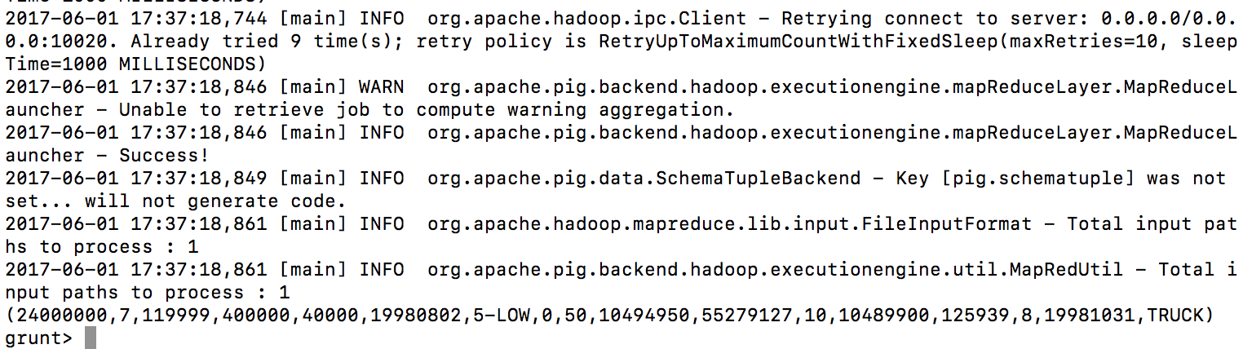

LO_SS = FOREACH lineorder GENERATE lo_linenumber, lo_quantity, lo_discount, lo_tax;

STORE LO_SS INTO '/user/ec2-user/pig_lo_ss.csv' USING PigStorage(' ')

Result:

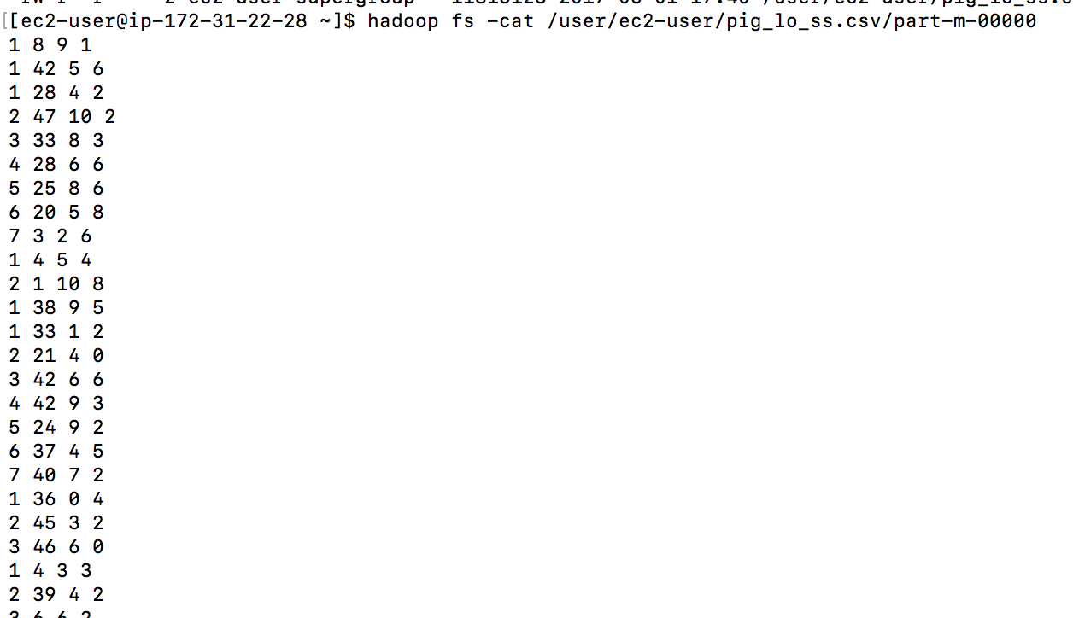

1. Create a pre-join (i.e. a new data file) that corresponds to the following query below.

Hive

CREATE TABLE dwdate ( d_datekey int, d_date varchar(19), d_dayofweek varchar(10), d_month varchar(10), d_year int, d_yearmonthnum int, d_yearmonth varchar(8), d_daynuminweek int, d_daynuminmonth int, d_daynuminyear int, d_monthnuminyear int, d_weeknuminyear int, d_sellingseason varchar(13), d_lastdayinweekfl varchar(1), d_lastdayinmonthfl varchar(1), d_holidayfl varchar(1), d_weekdayfl varchar(1) )ROW FORMAT DELIMITED FIELDS TERMINATED BY '|' STORED AS TEXTFILE;

LOAD DATA LOCAL INPATH '/home/ec2-user/dwdate.tbl' OVERWRITE INTO TABLE dwdate;

INSERT OVERWRITE DIRECTORY 'prejoin_hive' ROW FORMAT DELIMITED FIELDS TERMINATED BY ' ' SELECT lo_partkey, lo_suppkey, d_year, lo_revenue FROM lineorder, dwdate WHERE lo_orderdate=d_datekey;

Prejoin file:

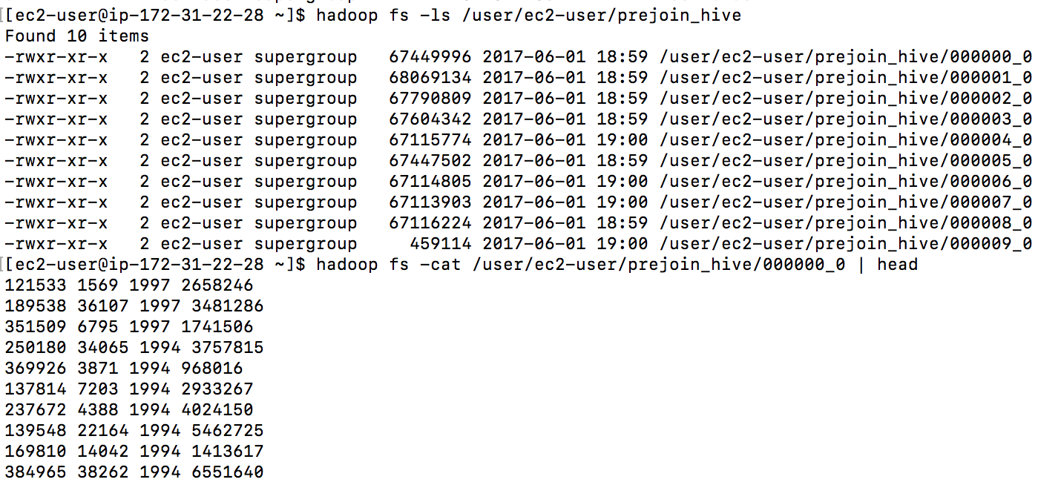

File size:

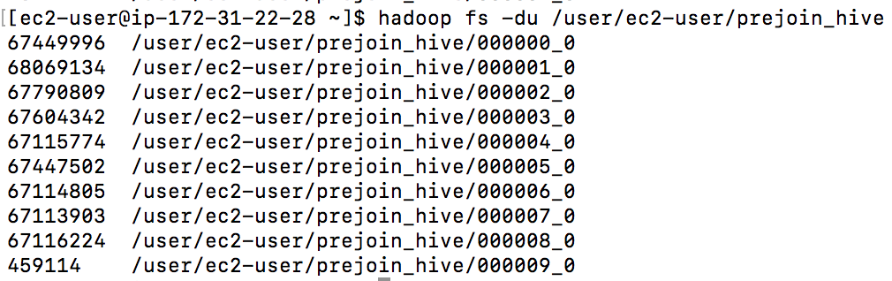

hadoop fs -du /user/ec2-user/prejoin_hive/

Pig

We have already created table lineorder; now Create table dwdate:

dwdate = LOAD '/data/dwdate_s4.tbl' USING PigStorage('|') AS (d_datekey: int, d_date: chararray, d_dayofweek: chararray, d_month: chararray, d_year: int, d_yearmonthnum: int, d_yearmonth: chararray, d_daynuminweek: int, d_daynuminmonth: int, d_daynuminyear: int, d_monthnuminyear: int, d_weeknuminyear: int, d_sellingseason: chararray, d_lastdayinweekfl: chararray, d_lastdayinmonthfl: chararray, d_holidayfl: chararray, d_weekdayfl: chararray);

join1 = JOIN lineorder BY lo_orderdate, dwdate BY d_datekey;

join2 = FOREACH join1 GENERATE lo_partkey, lo_suppkey, d_year, lo_revenue;

STORE join2 INTO '/user/ec2-user/pigprejoin_lo_s4.csv' USING org.apache.pig.piggybank.storage.CSVExcelStorage();

Result:

hadoop fs -ls /user/ec2-user/pigprejoin_lo_s4.csv

hadoop fs -cat /user/ec2-user/pigprejoin_lo_s4.csv/part-r-00000 | head

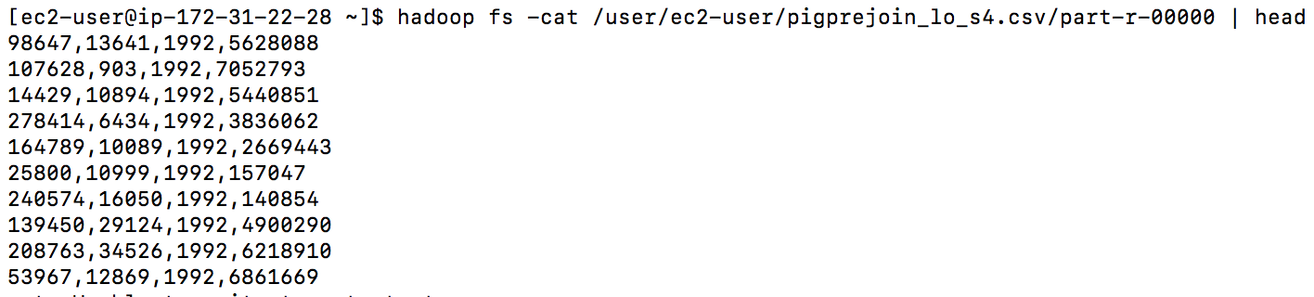

file size:

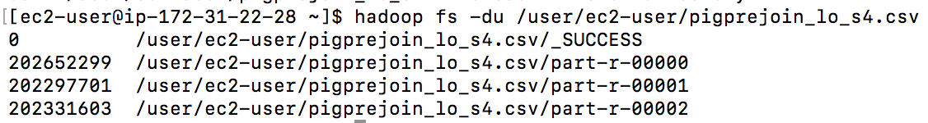

# Part 2: Querying

1. Run SSBM queries 3.1 and 4.1 using any one tool (Hive is the easiest by far)

wget <http://rasinsrv07.cstcis.cti.depaul.edu/CSC553/data/customer.tbl>

wget <http://rasinsrv07.cstcis.cti.depaul.edu/CSC553/data/supplier.tbl>

wget http://rasinsrv07.cstcis.cti.depaul.edu/CSC553/data/part.tbl

hadoop fs -put customer.tbl /data/customer_s4.tbl

hadoop fs -put supplier.tbl /data/supplier_s4.tbl

hadoop fs -put part.tbl /data/part_s4.tbl

query 3.1

CREATE TABLE customer ( c_custkey int, c_name varchar(25), c_address varchar(25), c_city varchar(10), c_nation varchar(15), c_region varchar(12), c_phone varchar(15), c_mktsegment varchar(10) )ROW FORMAT DELIMITED FIELDS TERMINATED BY '|' STORED AS TEXTFILE;

LOAD DATA LOCAL INPATH '/home/ec2-user/customer.tbl' OVERWRITE INTO TABLE customer;

CREATE TABLE part ( p_partkey int, p_name varchar(22), p_mfgr varchar(6), p_category varchar(7), p_brand1 varchar(9), p_color varchar(11), p_type varchar(25), p_size int, p_container varchar(10) )ROW FORMAT DELIMITED FIELDS TERMINATED BY '|' STORED AS TEXTFILE;

LOAD DATA LOCAL INPATH '/home/ec2-user/part.tbl' OVERWRITE INTO TABLE part;

CREATE TABLE supplier ( s_suppkey int, s_name varchar(25), s_address varchar(25), s_city varchar(10), s_nation varchar(15), s_region varchar(12), s_phone varchar(15) )ROW FORMAT DELIMITED FIELDS TERMINATED BY '|' STORED AS TEXTFILE;

LOAD DATA LOCAL INPATH '/home/ec2-user/supplier.tbl' OVERWRITE INTO TABLE supplier;

SELECT c_nation, s_nation, d_year, sum(lo_revenue) as revenue FROM customer, lineorder, supplier, dwdate WHERE lo_custkey = c_custkey and lo_suppkey = s_suppkey and lo_orderdate = d_datekey and c_region = 'ASIA' and s_region = 'ASIA' and d_year between 1992 and 1997 and d_year >= 1992 and d_year <= 1997 GROUP BY c_nation, s_nation, d_year ORDER BY d_year asc, revenue asc;

Result:

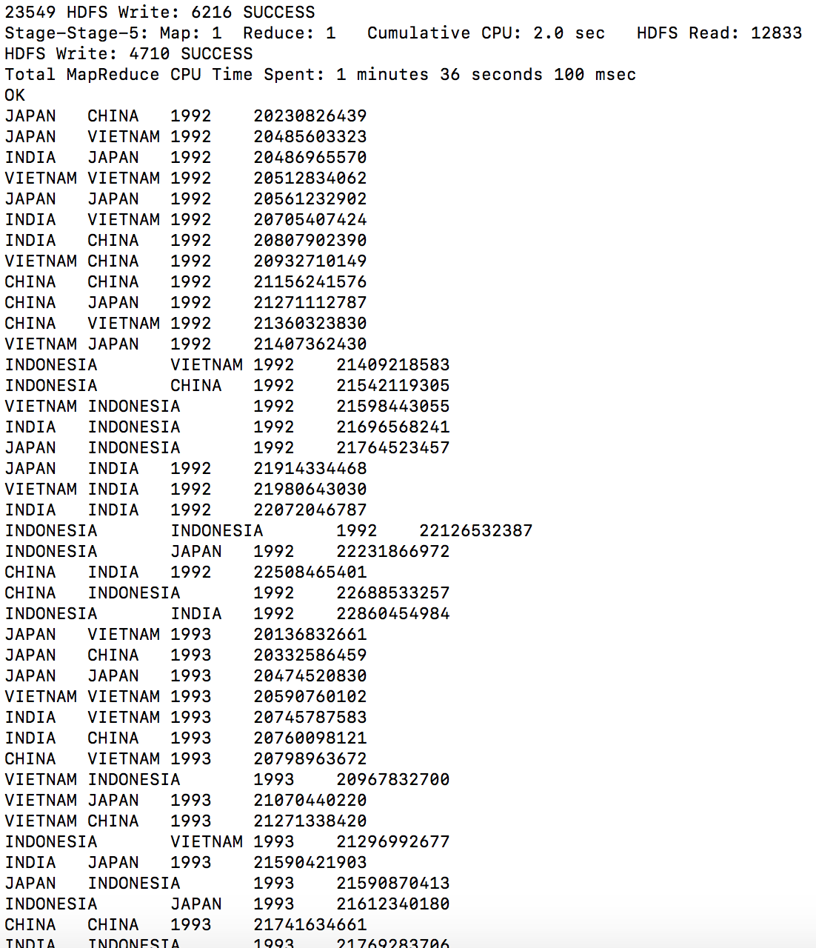

Time taken:

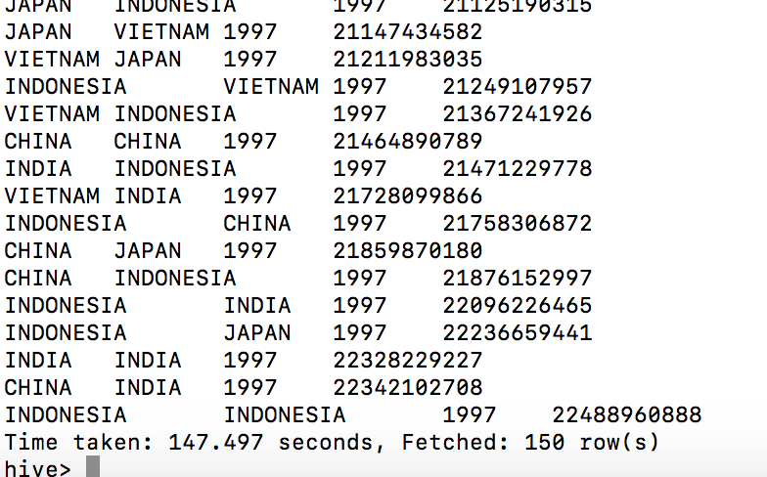

query 4.1

select d_year, c_nation, sum(lo_revenue) as profit1 from lineorder, dwdate, customer, supplier, part where lo_custkey = c_custkey and lo_suppkey = s_suppkey and lo_partkey = p_partkey and lo_orderdate = d_datekey and c_region = 'AMERICA' and s_region = 'AMERICA' and p_mfgr = 'MFGR#1' group by d_year, c_nation;

result:

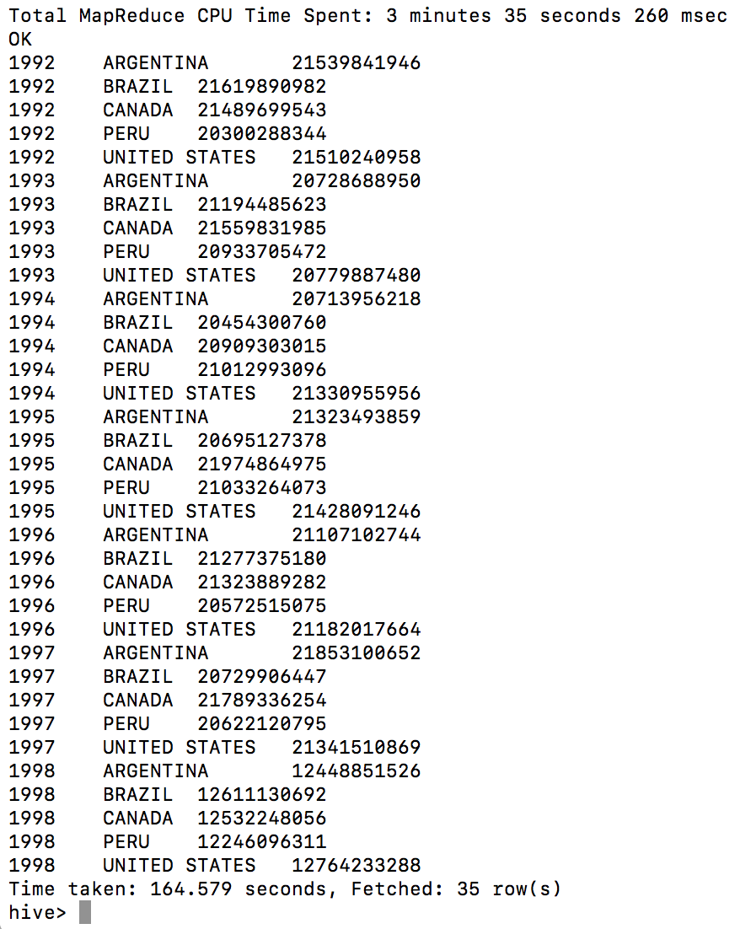

1. For this part you should use two of the three choices (Hive, Pig, Hadoop Streaming) to run Q2.1 using what you have created in 1-D

HIVE:

CREATE TABLE ldjoin (lo_partkey int, lo_suppkey int, d_year int, lo_revenue int)ROW FORMAT DELIMITED FIELDS TERMINATED BY ' ' STORED AS TEXTFILE;

LOAD DATA INPATH '/user/ec2-user/prejoin_hive' OVERWRITE INTO TABLE ldjoin;

SELECT COUNT(lo_revenue) FROM ldjoin;

select sum(lo_revenue), d_year, p_brand1 from ldjoin, part, supplier where lo_partkey = p_partkey and lo_suppkey = s_suppkey and p_category = 'MFGR#12' and s_region = 'AMERICA' group by d_year, p_brand1 order by d_year, p_brand1;

result:

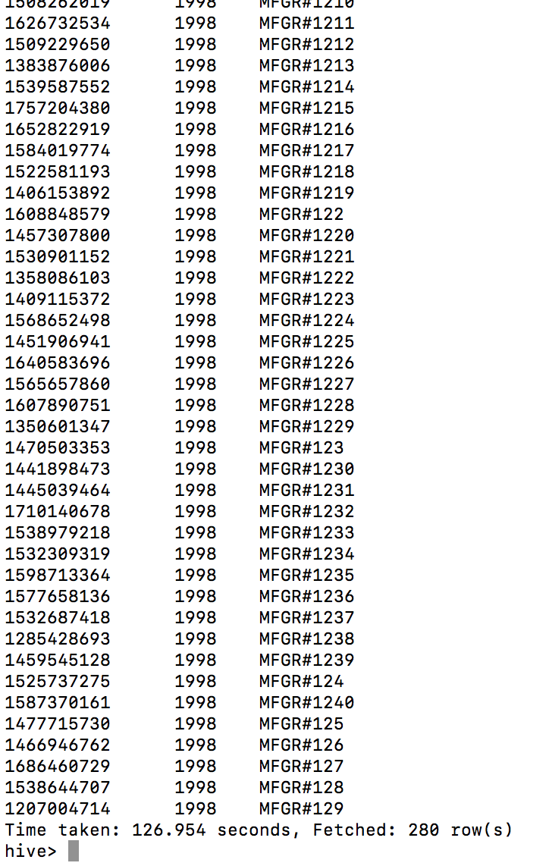

PIG:

hadoop fs -put part.tbl /data/part_s4.tbl

hadoop fs -put supplier.tbl /data/supplier_s4.tbl

supplier = LOAD '/data/supplier_s4.tbl' USING PigStorage('|') AS (s_suppkey:int, s_name:CHARARRAY, s_address:CHARARRAY, s_city:CHARARRAY, s_nation:CHARARRAY, s_region:CHARARRAY, s_phone:CHARARRAY);

part = LOAD '/data/part_s4.tbl' USING PigStorage('|') AS (p_partkey:int, p_name:CHARARRAY, p_mfgr:CHARARRAY, p_category:CHARARRAY, p_brand1:CHARARRAY, p_color:CHARARRAY, p_type:CHARARRAY, p_size:int, p_container:CHARARRAY);

ldjoin = LOAD ' /user/ec2-user/pigprejoin_lo_s4.csv' USING PigStorage(',') AS (lo_partkey:int, lo_suppkey:int, d_year:int, lo_revenue:int);

F_part = FILTER part BY p_category == 'MFGR#12';

F_supplier = FILTER supplier BY s_region == 'AMERICA';

join1= JOIN ldjoin BY lo_partkey, F_part BY p_partkey;

join2= JOIN join1 BY lo_suppkey, F_supplier BY s_suppkey;

GB = GROUP join2 BY (d_year, p_brand1);

GE = FOREACH GB GENERATE SUM(join2.lo_revenue) as revenue, join2.d_year as d_year, join2.p_brand1 as p_brand1;

RLT = ORDER GE BY d_year, p_brand1;

DUMP RLT;

Result:

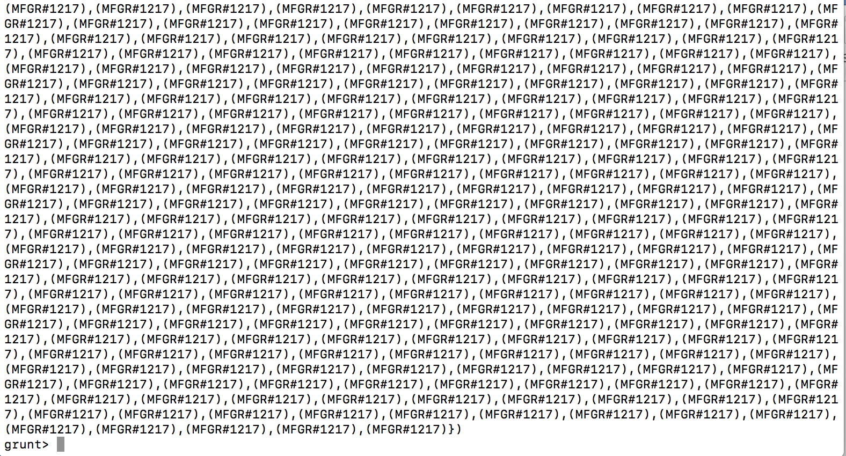

time: 15 min 53 seconds

start



end

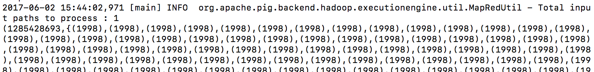

# Part 3: Clustering

Using the file you have created in 1-C, run KMeans clustering using 8 clusters.

1. Using Mahout as you have in a previous assignment

Copy the data from 1-C hive result to be in the folder testdata so that mahout could read it. And then run the kmeans command as below(k=8):

mahout org.apache.mahout.clustering.syntheticcontrol.kmeans.Job -i testdata -o output -t1 3 -t2 1.5 -cd 0.5 -x 10 -k 8

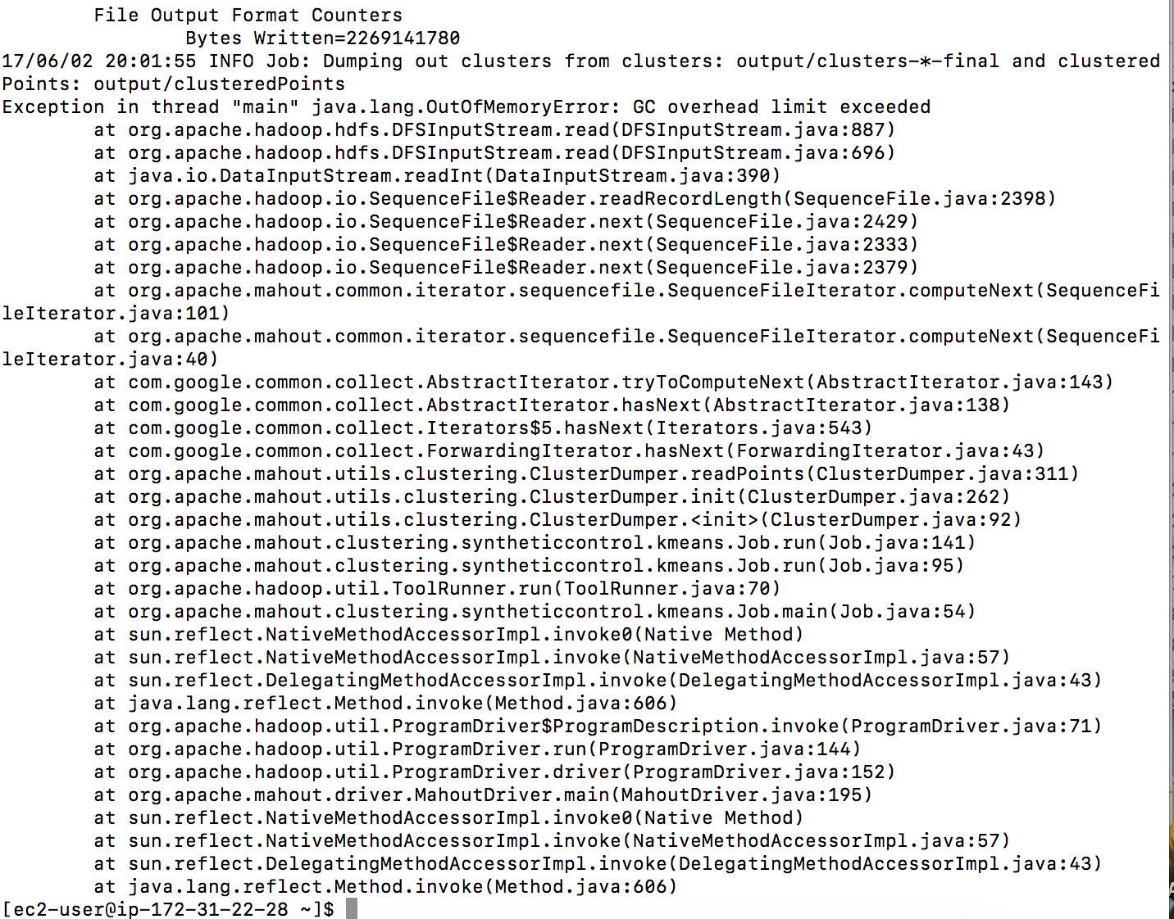

mahout clusterdump -i output/clusters-10-final -p output/clusteredPoints -o clusteranalyze.txt

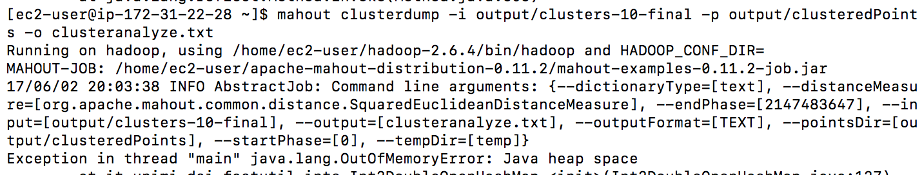

edit the marped site.xml:

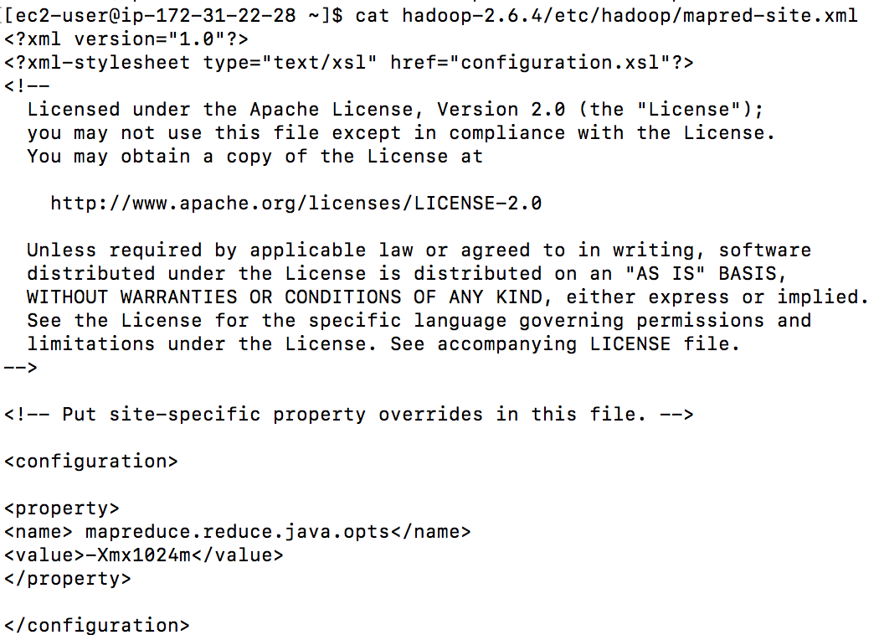

result: still have the same error

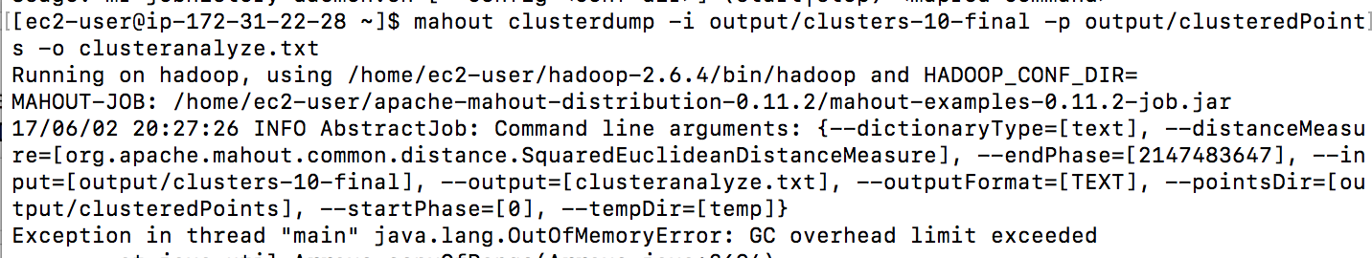

1. Using Hadoop streaming perform two iterations (manually) with randomly chosen input centers.

Iteration 1:

Mapper and reducer code:

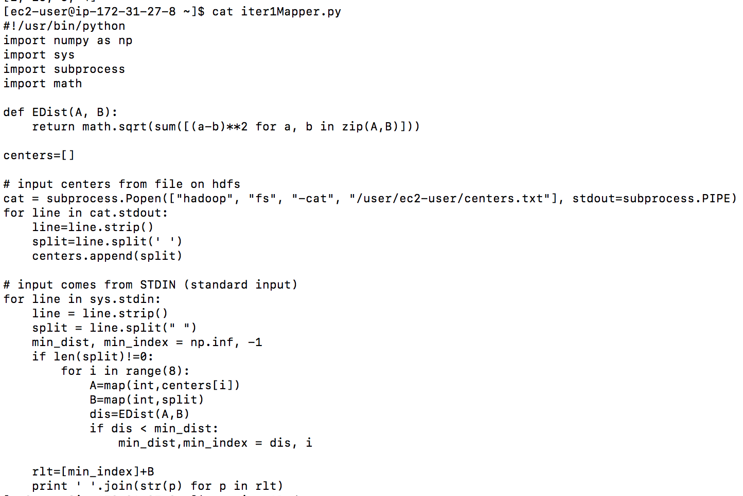

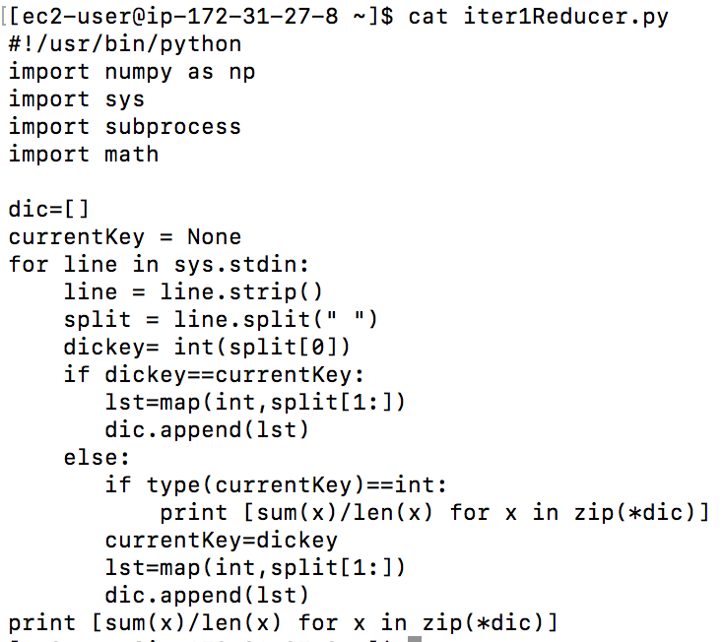

**Center points(8): assigned in file centers.txt**

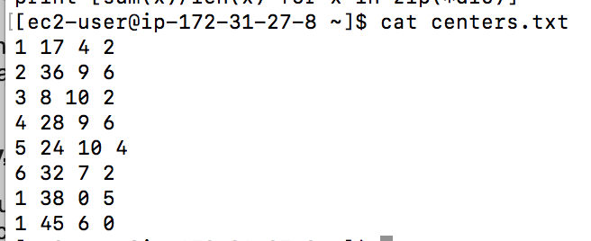

Test the MR on one file in the input folder first:

hadoop jar hadoop-streaming-2.6.4.jar -input /user/ec2-user/lo_ss/000000_0 -output /data/kmeans_out77 -mapper iter1Mapper.py -reducer iter1Reducer.py -file iter1Reducer.py -file iter1Mapper.py

result: give 8 new centers after iteration 1 for next step’s distance calculation.

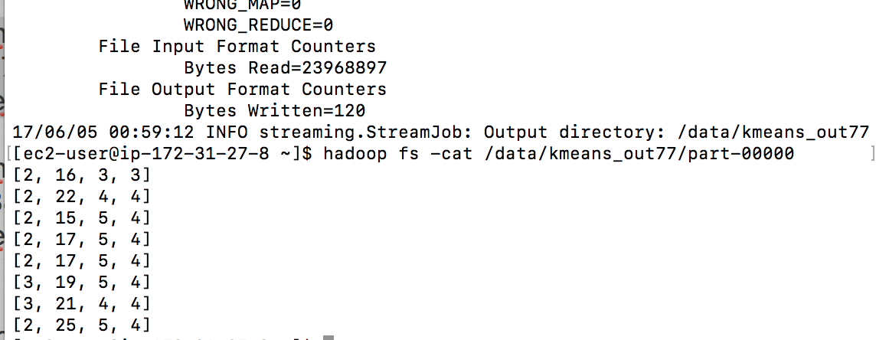

Now change the input to be the folder with all the data files:

Hadoop jar streaming:

hadoop jar hadoop-streaming-2.6.4.jar -input /user/ec2-user/lo_ss/ -output /data/kmeans_out666 -mapper iter1Mapper.py -reducer iter1Reducer.py -file iter1Reducer.py -file iter1Mapper.py

result:

change the mapred-site.xml as instructed, but still cannot reach a result due to memory limit.

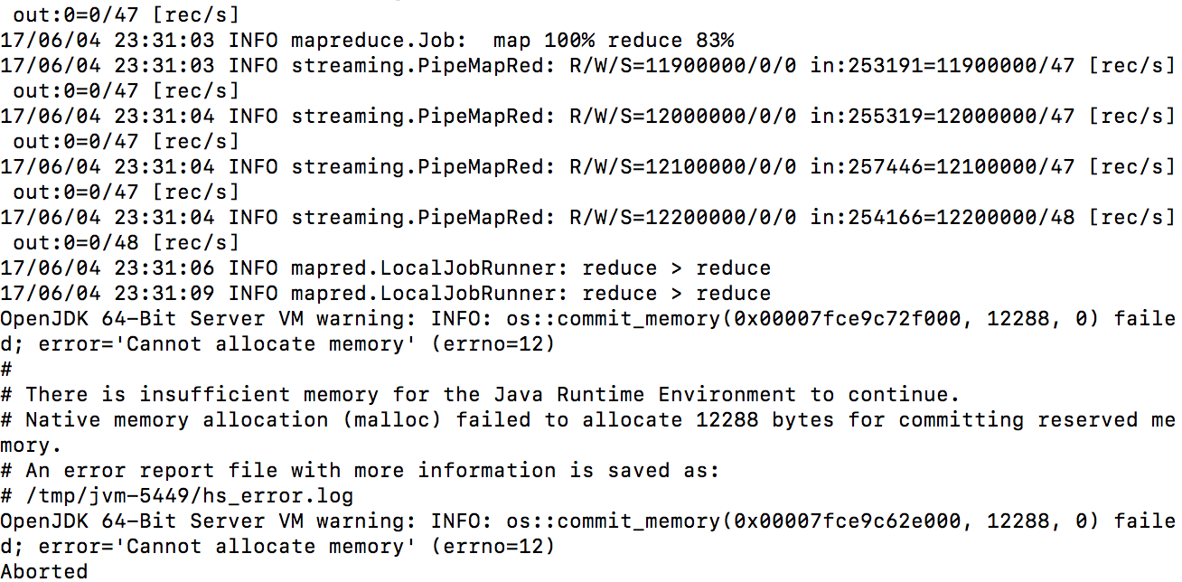

iteration 2:

replace centers with the output from last step, which is the new centers and repeat the process and gives out a new set of centers, when the centers stabilize then we could give out clustering result.

We will give a result based on the one file 000000_0 for we had the memory problem to process all the files from last iteration.

the iter2Mapper.py is same as iter1Mapper.py except that the centers.txt is updated to be the new centers generated from iteration 1.

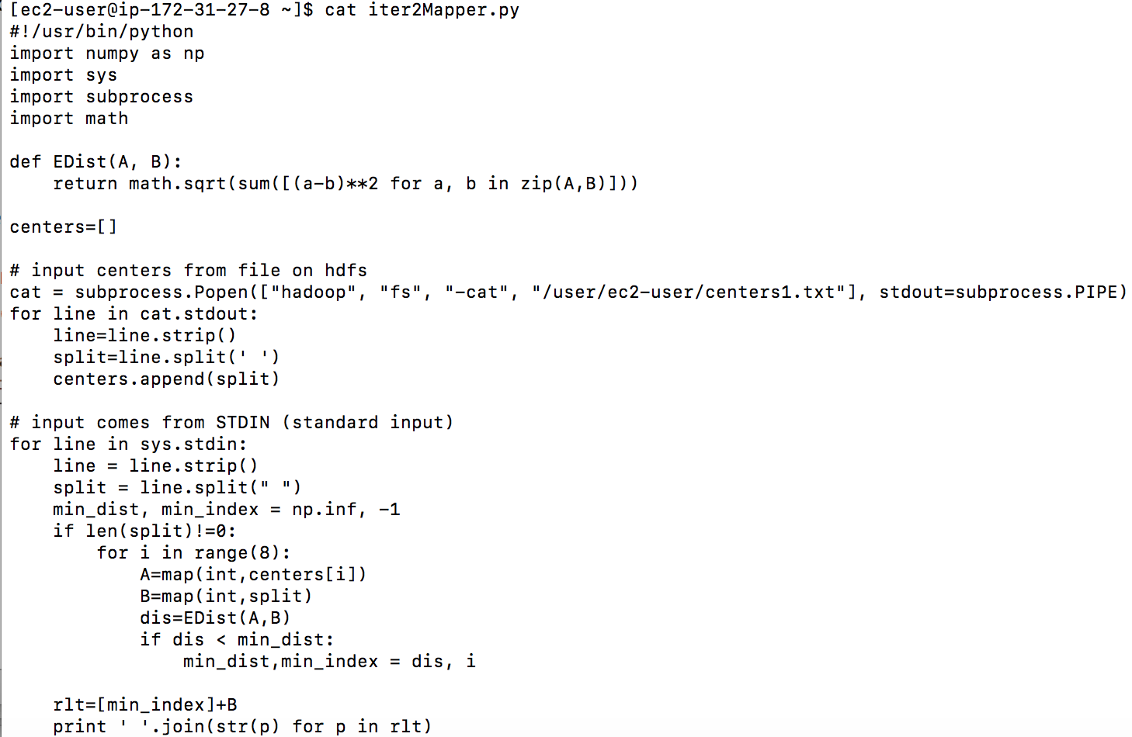

And the reducer code is the old one.

hadoop jar hadoop-streaming-2.6.4.jar -input /user/ec2-user/lo_ss/000000_0 -output /data/kmeans_out99 -mapper iter2Mapper.py -reducer iter1Reducer.py -file iter1Reducer.py -file iter2Mapper.py

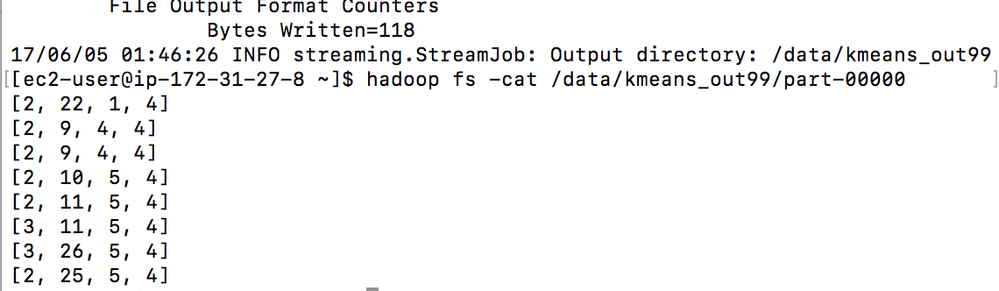

# Part 4: Performance

1. Both of your solutions to Part-1A # EXAPLAIN HOW THINGS SCALES BY TIME AND NUBMER OF NODES
   1. Scale4: single node and a cluster of at least 4 nodes

CLUSTER OF 4 NODES:

PIG:

PIG Time Taken:4 min 9 seconds

Start



End



HIVE:



SINGLE NODE(command is same as in cluster, just using one node instead)

PIG: 6 min 54 seconds

Start:



End:



HIVE:

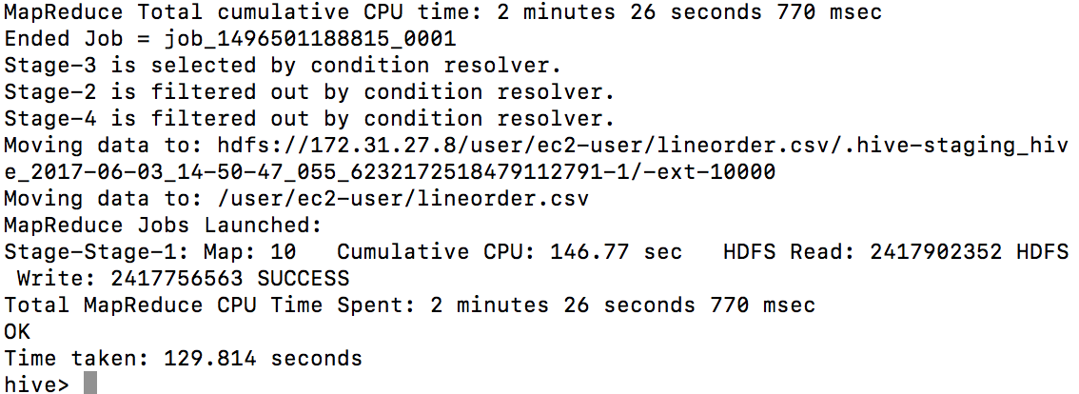

* 1. Scale14: cluster of at least 4 nodes

HIVE:

wget http://rasinsrv07.cstcis.cti.depaul.edu/CSC553/data/Scale14/lineorder.tbl

hadoop fs -put lineorder.tbl.1 /data/lineorder_s14.tbl

hadoop fs -ls /data # checked, everything is fine

cd $HIVE_HOME

bin/home

CREATE TABLE lineorder14 ( lo_orderkey int, lo_linenumber int, lo_custkey int, lo_partkey int, lo_suppkey int, lo_orderdate int, lo_orderpriority varchar(15), lo_shippriority varchar(1), lo_quantity int, lo_extendedprice int, lo_ordertotalprice int, lo_discount int, lo_revenue int, lo_supplycost int, lo_tax int, lo_commitdate int, lo_shipmode varchar(10) )ROW FORMAT DELIMITED FIELDS TERMINATED BY '|' STORED AS TEXTFILE;

LOAD DATA INPATH '/data/lineorder_s14.tbl' OVERWRITE INTO TABLE lineorder14;

INSERT OVERWRITE DIRECTORY '/user/ec2-user/lineorder_s14.csv' ROW FORMAT DELIMITED FIELDS TERMINATED BY ',' SELECT * FROM lineorder14;

Time taken: 394.479 seconds

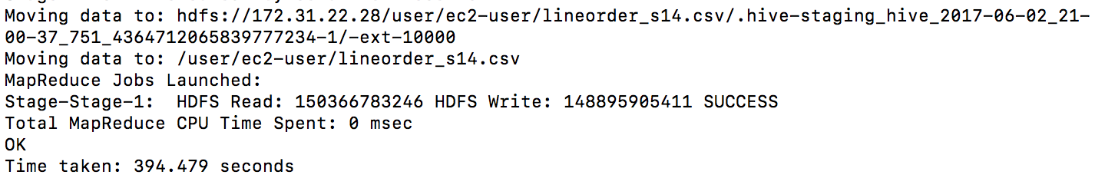

Check out result:

Hadoop fs –cat /user/ec2-user/lineorder_s14.csv/ | head

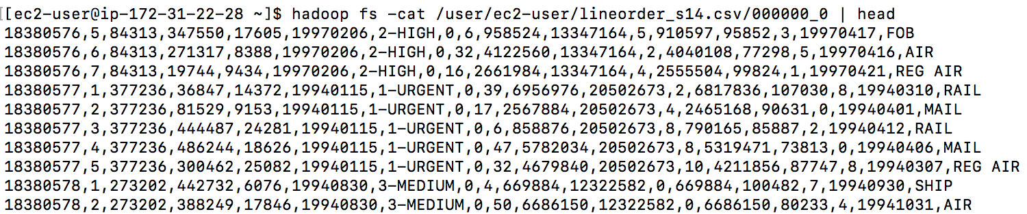

PIG:

lineorder = LOAD '/data/lineorder_s14.tbl' USING PigStorage('|')AS (lo_orderkey: int, lo_linenumber: int, lo_custkey: int, lo_partkey: int, lo_suppkey: int, lo_orderdate: int, lo_orderpriority: chararray, lo_shippriority: chararray, lo_quantity: int, lo_extendedprice: int, lo_ordertotalprice: int, lo_discount: int, lo_revenue: int, lo_supplycost: int, lo_tax: int, lo_commitdate: int, lo_shipmode: chararray);

STORE lineorder INTO '/user/ec2-user/lineorder14_pig.csv' USING org.apache.pig.piggybank.storage.CSVExcelStorage();

PIG Time Taken: 7 minutes

Start

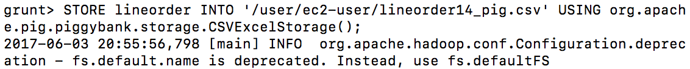

End



B--Both of your solutions for 2-B.

Scale4: single node and a cluster of at least 4 nodes

CLUSTER OF 4 NODES:

PIG:

time: 15 min 53 seconds

start



end



HIVE:

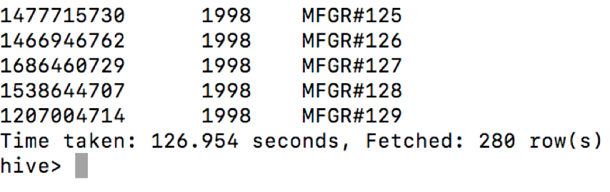

SINGLE NODE:

PIG:

start

end:

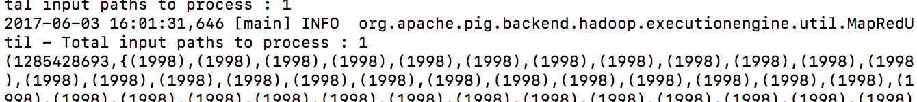

HIVE:

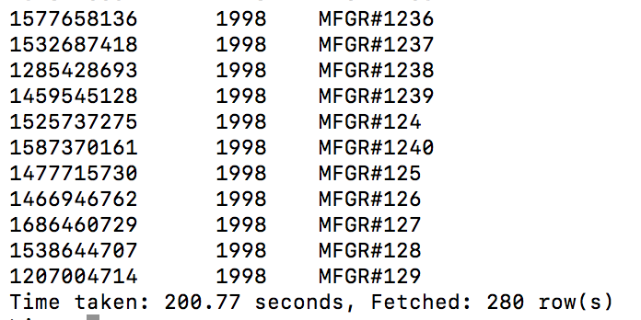

Summarize the results and cluster performance/scaling:

Pig takes more time to process queries than hive overall; one node takes more time than cluster of nodes to process tasks; when data scale up, the time it takes to process a task is much longer, as it also takes extra space and time to save and distribute the file on hdfs.